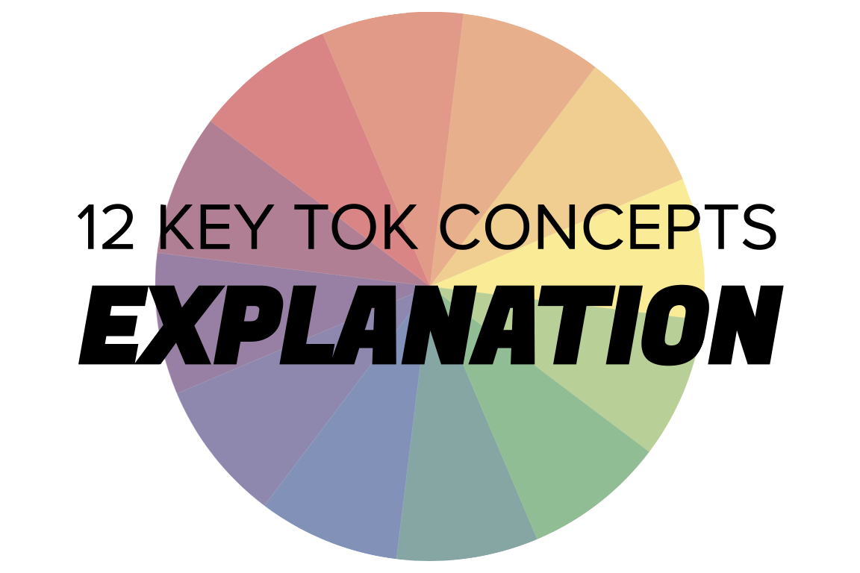 | EXPLANATION

Understanding the 12 key concepts
- The 12 key concepts are ones that have been identified as having a particular significant relationship to knowledge.
- Understanding, exploring, and using these concepts will help you to understand the way knowledge is produced and used, within the core and optional themes, and the areas of knowledge.
- You should also try to use the key concepts as extensively as possible in the two TOK assessment tasks.
Starting points for explanation  - How many online definitions can you find for ‘explanation’?  - Which one do you think best sums up this concept, and why?  - Which of the quotes below do you think provides us with the best insight into explanation? Are there any you disagree with?  - What constitutes an effective explanation for you?  - How might the possession of power change the way we understand the world? | Quotes on explanation  - To one who has faith, no explanation is necessary. To one without faith, no explanation is possible. Thomas Aquinas  - A little inaccuracy sometimes saves a ton of explanation. Hector Hugh Munro  - The reason people turn to supernatural explanations is that the mind abhors a vacuum of explanation. Because we do not yet have a fully natural explanation for mind and consciousness, people turn to supernatural explanations to fill the void. Michael Shermer  - Explanation separates us from astonishment, which is the only gateway to the incomprehensible. Eugene Ionesco  - If I have learned anything as a scientist, it is that one should not make things complicated when a simple explanation will do. Ivar Giaever
Interlinking the key concepts  - How do explanations vary from justifications?  - Can we explain anything without evidence?  - Do our explanations depend on our perspective?  - Do our values help or hinder us from explaining the world?  - What’s the difference between explaining something, and interpreting it? | Relating explanation to the TOK course  - Is our ability to explain wholly dependent on our ability to use language?  - In which areas of knowledge are explanations easiest/most difficult to construct?  - Does technology help or hinder our ability to explain our claims?  - How do indigenous explanations about the world differ from those in large-scale societies?
Relating explanation to the TOK exhibition  - IAP-4: Think about how an explanation might make us doubt a claim  - IAP-10: Think about the challenges associated with communicating knowledge via explanations  - IAP-24: Think about how the context of an explanation determines whether knowledge will be accepted or rejected  - IAP-32: Think about what constitutes a good explanation | Relating explanation to the Big Questions  - BQ1 - What are the key ways of explaining ideas?  - BQ2 - What represents a ‘moral’ and an ‘immoral’ way of explaining ideas?  - BQ3 - How does the form of explanation change the nature of our understanding?  - BQ4 - Does our ability to explain knowledge depend on our perspective?  - BQ5 - How have forms of explanations changed over time?  - BQ6 - Is clarity of explanation the key characteristic of expert thinkers?

Real-world contexts for explanation
The media sources below explicitly mention explanation, and discuss this key concept in a real-world context. Use the find command (ie Command/Control+F) to locate the term in the article or transcript of the video, and you’ll see where it features. Check back regularly, as we update these media sources every month.
Big Question / knowledge framework | Description of media source and story and links to the course
BQ3 / Methods & tools | An Atlantic article, arguing that the word ‘problematic’ is misused by people. Language, Human sciences
BQ4 / Perspectives | A Guardian article, reporting on analysis that suggests female scientists are less likely to be credited for new discoveries. Natural sciences, Human sciences
BQ5 / Methods & tools | A Guardian article, which considers whether machine learning means the end of the scientific method. Natural sciences, Technology, Mathematics  A New Humanist podcast, featuring Carlo Rovelli, referred to by some as the ‘poet of physics’ for his work on quantum theory. Natural sciences, Mathematics, Technology, Knowledge & the knower  A Vox article, examining the reports that the US and other Western governments are treating accusations that Covid began in a lab increasingly seriously. Natural sciences, Human sciences, politics, knowledge & the knower  A Big Think article, looking at the claims of an astrophysicist that ‘dark fluid’ represents the missing 95% of the mass of the universe. Natural sciences, mathematics

